Top Tips: Use this press release before your event if you would like to invite people in your area to attend.
Edit the sections in pink with your own information and email it to your local newspaper and radio station around two weeks before your event. Don’t forget to proofread before sending and remove any pink text and instructions.
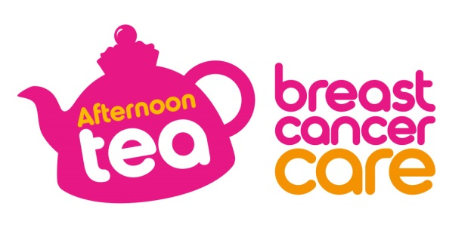

[Insert date]
[Insert name of town/area] [Woman/ man/ friends/ group] to host Afternoon Tea to support people facing breast cancer
[Name] from [Location] is hosting an Afternoon Tea at [Venue] on [Date] to raise money for Breast Cancer Care to ensure no one in [name of town], or anywhere in the UK, has to face breast cancer alone.
[Name], [Age] is holding [his/her/their] [first/second/third annual] Afternoon Tea and is encouraging people to come along and support the charity.
[Name] who works as an [occupation] says: [Select any of the following three options, edit or expand if you want].
“My [family member/friend] was diagnosed with breast cancer in [month/year] and I am looking forward to giving something back by hosting an Afternoon Tea to raise money for Breast Cancer Care.”
OR “I was diagnosed with breast cancer in [month/year] and I am looking forward to hosting an Afternoon Tea to say thank you to my friends and family for their support, while raising money for Breast Cancer Care.”
OR “I am looking forward to holding an Afternoon Tea as it’s a fun way to bring together people from the local community while also raising money for Breast Cancer Care.”
“We’d love locals to join us for some delicious scones, sandwiches and cakes. [Include if relevant]: There will also be games and competitions too so there’s something for everyone.”
Samia al Qadhi, Chief Executive at Breast Cancer Care, added: “We’re so grateful to everyone who holds an Afternoon Tea in aid of Breast Cancer Care this summer. The money raised will enable Breast Cancer Care to continue to provide vital support for the 691,000 people living with breast cancer in the UK today.”
If you would like to attend [Name]’s Afternoon Tea, please call [phone number]
OR
[Name]’s Afternoon Tea is being held at [Full address] on [insert date] between [time-time]/ at [time], locals are welcome to drop by.
If you’d like to hold your own Afternoon Tea you can order a free fundraising kit at www.breastcancercare.org.uk/cuppa or call 0300 100 4442.
– Ends –

For further information, images or interviews contact:
[Name], [Phone number], [Email address]

About Breast Cancer Care
Breast Cancer Care is the only specialist UK wide charity providing support for women, men, family and friends affected by breast cancer. We’ve been caring for them, supporting them, and campaigning on their behalf since 1973.
Today, we continue to offer a unique range of support including reliable information, one-to-one support over the phone and online from nurses and people who’ve been there. We also offer local group support across the UK.
From the moment someone notices something isn’t right, through to their treatment and beyond, we’re there to help people affected by breast cancer feel more in control. breastcancercare.org.uk

