Use this press release before your event if you would like to invite local people to attend. Edit the sections in pink with your own information and email it to your local newspaper and radio station around two weeks before your event. Don’t forget to proofread before sending and remove any pink text and instructions.
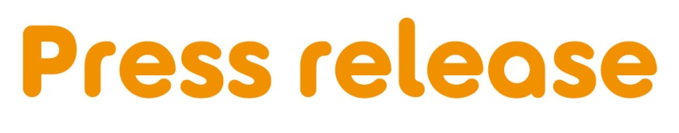
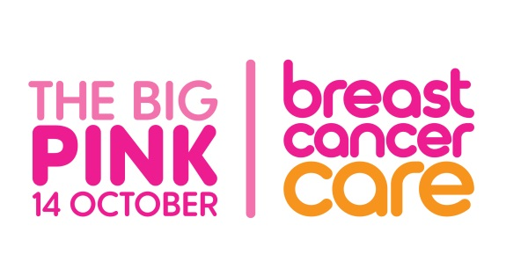
[Insert date]
[Insert name of town/area] [woman/man/friends/group] is in the Pink for people affected by breast cancer!
On [date] October, [name], [age], from [location] is holding a Big Pink [insert details of event here - dress down day at work /girls night in/ pink lunch with neighbours?] at [venue] for Breast Cancer Care – the only UK-wide specialist breast cancer support charity.
[Name] is holding their Big Pink event because [insert info on why you are doing the fundraiser. E.g. to support a family member who has been diagnosed, to support people with breast cancer.]
[Name], who works as a [job], says: “[insert a quote here outlining: How are feeling about hosting the event? Is it your first? Where are you holding it? What are you planning on doing to raise money? Just give as much information as you can about you, your reasons for supporting Breast Cancer Care and your event].”
Fiona West, Fundraising Officer at Breast Cancer Care, added: “We’re so grateful to [Name] for holding a Big Pink event in aid of Breast Cancer Care. With the help of supporters like [Name] we can provide care, support and information to anyone affected by breast cancer. An estimated 691,000 people in the UK are currently living with a breast cancer diagnosis so there has never been such an urgent need for our support services.”
[If you would like people to join your Big Pink, incude the following] [Name]’s Big Pink will take place at [Location], [Address] at [start time – end time]. Everyone welcome.
Want to hold your own Big Pink in Breast Cancer Awareness Month this October? It can be as fuss-free as you like – from a dress down day at work, pink night in or pub quiz. Anything goes… as long as it’s pink! Every penny will help Breast Cancer Care to continue to support anyone affected by breast cancer. Join in on 14 October – or choose a date to suit you.
Find out more and get a free fundraising kit at www.breastcancercare.org.uk/bigpink
– Ends –

Notes to Editors

For further information please contact:
Insert contact details including [Name], [email address], [phone number]

About Breast Cancer Care

When you have breast cancer, everything changes. Time becomes measured in appointments. The next scan. The next results. The next challenge.

At Breast Cancer Care, we understand the emotions, challenges and decisions you face every day. So, from the day you notice something’s not right to the day you begin to move forward, we’ll be here to help you through.

Whether you want to speak to our nurses, download our specialist information or connect with volunteers who have faced what you are facing now, we can help you feel more in control.

For care, support and information from day one, call us free on 0808 800 6000 or visit breastcancercare.org.uk

