Top Tips: Use this press release before your event if you would like to invite local people to attend. Edit the sections in pink with your own information and email it to your local newspaper and radio station around two weeks before your event. Don’t forget to proofread before sending and remove any pink text and instructions.
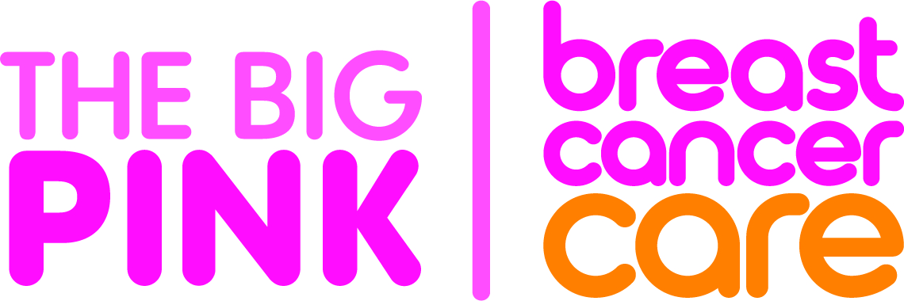
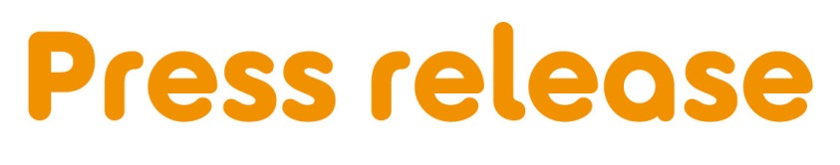
[Insert date]
[Insert name of town/area] [woman/ man/ friends/ company] to host Big Pink to support families facing breast cancer
[Full Name/ Company name] from [Location] is hosting a Big Pink at [Venue] on [Date] to raise awareness and money for Breast Cancer Care – the only UK-wide specialist breast cancer support charity, for Breast Cancer Awareness Month this October.
[First Name], [Age] is holding [his/her/their] [first/second/third annual] Big Pink and is encouraging people to come along and support the charity.
[Name] who works as an [occupation] says: [Select any of the following three options, edit or expand if you want].
“My [family member/ friend/ colleague] was diagnosed with breast cancer in [month/ year] and I am looking forward to giving something back by hosting a Big Pink to raise money for Breast Cancer Care.”
OR “I was diagnosed with breast cancer in [month/ year] and I am looking forward to hosting a Big Pink to say thank you to my [friends and family/ colleagues] for their support, while raising money for Breast Cancer Care.”
OR “I am looking forward to holding a Big Pink as it’s a fun way to bring together people from the local community while also raising awareness and money for Breast Cancer Care.”
“We’d love locals to join us for some delicious pink treats. [Include if relevant]: There will also be games and competitions too so there’s something for everyone.”
Fiona West, Fundraising Officer at Breast Cancer Care, added: “We’re so grateful to [Name] for holding a Big Pink in aid of Breast Cancer Care. The money [he/she/they] raises will help the charity to continue to provide a unique range of free support including; reliable information, one-to-one support over the phone and online from nurses and people who’ve been diagnosed themselves. An estimated 691,000 people in the UK are currently living with a breast cancer diagnosis so there has never been such an urgent need for our support services.”
If you would like to attend [Name]’s Big Pink, please call [phone number]
[Or]
[Name]’s Big Pink is being held at [Full address] on [insert date] between [time-time]/ at [time], locals are welcome to drop by.
Want to hold your own Big Pink in Breast Cancer Awareness Month this October? It can be as simple as a pink night in at home, a bake sale with your colleagues or a pink party in the community. Big or small, the money you raise will help Breast Cancer Care to transform the lives of people affected by the disease.
Get your free kit today and you’ll receive everything you need to get started. Visit breastcancercare.org.uk/October
– Ends –

For further information, images or interviews contact:
[Name], [Phone number], [Email address]

About Breast Cancer Care
When you have breast cancer, everything changes. Time becomes measured in appointments. The next scan. The next results. The next challenge.

At Breast Cancer Care, we understand the emotions, challenges and decisions you face every day. So, from the day you notice something’s not right to the day you begin to move forward, we’ll be here to help you through.

Whether you want to speak to our nurses, download our specialist information or connect with volunteers who have faced what you are facing now, we can help you feel more in control.

For care, support and information from day one, call us free on 0808 800 6000 or visit breastcancercare.org.uk

