Use this press release before your event if you would like to invite local people to attend. Edit the sections in red with your own information and email it to your local newspaper and radio station around two weeks before your event. Don’t forget to proofread before sending and remove any red text and instructions.
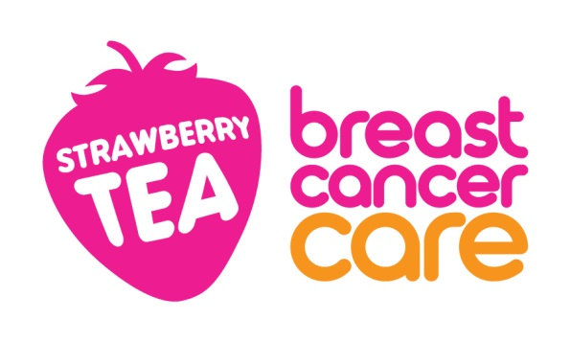

<Insert date>
<Insert name of town/area> <woman/man/friends/group> to host a Strawberry Tea to help people facing breast cancer
<Name> from <Location> is hosting a Strawberry Tea at <Venue> on <Date> for Breast Cancer Care – the only UK-wide specialist breast cancer support charity.
<Name>, <Age> is holding <his/her/their> <first/second/third annual> Strawberry Tea and is encouraging local residents to come along and support people facing breast cancer.
<Name> who works as an <occupation> says: (Select any of the following 3 options, edit or expand if you want.)
“My <family member/friend> was diagnosed with breast cancer in <month/year> and I am looking forward to giving something back by hosting a Strawberry Tea to raise money for Breast Cancer Care.”
OR “I was diagnosed with breast cancer in <month/year> and I am looking forward to hosting a Strawberry Tea to say thank you to my friends and family for their support, while raising money for Breast Cancer Care.”
OR “I am looking forward to holding a Strawberry Tea as it’s a fun way to bring together people from the local community while also raising money for Breast Cancer Care.”
“We’d love locals to join us for some delicious cakes/homebaked treats and a raffle/games.”
Georgie Burchell, Community Fundraising Marketing Officer at Breast Cancer Care, added: “We’re so grateful to <Name> for holding a Strawberry Tea in aid of Breast Cancer Care. The money <he/she/they> raises will help Breast Cancer Care continue to provided a unique range of support including reliable information, one-to-one support over the phone and online from nurses and people who’ve been diagnosed themselves. Every year around 58,000 people are diagnosed with breast cancer in the UK so there’s never been such an urgent need for our support services.”
Breast Cancer Care’s Strawberry Tea summer fundraising campaign, runs from 1 June – 31 August. All funds raised will help provide vital support for people living with breast cancer.
If you would like to attend <Name>’s Strawberry Tea, please call <phone number>
OR
<Name>’s Strawberry Tea is being held at <Full address> on <insert date> between <time-time>, locals are welcome to drop by.
If you’d like to hold your own Strawberry Tea you can order a free fundraising kit at breastcancercare.org.uk/strawberry or call 0300 100 4442.
– Ends –

For further information, images or interviews contact:
<Name>, <Phone number>, <Email address>

About Breast Cancer Care

When you have breast cancer, everything changes. Time becomes measured in appointments. The next scan. The next results. The next challenge.

At Breast Cancer Care, we understand the emotions, challenges and decisions you face every day. So, from the day you notice something’s not right to the day you begin to move forward, we’ll be here to help you through.

Whether you want to speak to our nurses, download our specialist information or connect with volunteers who have faced what you are facing now, we can help you feel more in control.

For care, support and information from day one, call us free on 0808 800 6000 or visit breastcancercare.org.uk

