Community Fundraising press pack

If you’re planning a fundraising event for Breast Cancer Care and are keen get your fundraising challenge more publicity, this is the guide for you. It includes tips on contacting your local media and a template press release. Please share any media coverage with us by emailing press@breastcancercare.org.uk.
Top tips
- Fill in the template release and send over to your local paper by email 3-4 weeks in advance of an event.
- If you have a photo, send a high quality version along with the release. We can provide you with stock images if you don’t have one.
- If you have time, you can ring the paper. You will need to contact the news desk; call the switchboard and ask to be put through to news.
- If they give you a news@.... email address ask if you can mark it for someone’s attention, then in the subject line put FAO John Smith.
- If it’s a daily paper, do not call before 11am or after 3.30pm. If it’s a weekly paper which is published on, for example, a Thursday, do not call on a Wednesday as these are their busiest times.
- The journalist may want to ask you more details, so be prepared to answer some questions about why you are taking part in your challenge and how much you hope to raise
- If you have had an experience of breast cancer, they may want to ask you more details. Please don't feel you have to talk about anything you do not feel comfortable with.
- The paper may want to send a photographer round to take a photo of you in your training kit.
- Do ask the journalist when the story might appear. They may even offer to send you a copy, but please try and look out for it.

Community event release
Please amend the template below, replacing your own details with the prompt text in <pink>. Make sure to delete any formatting/font instructions on the page before sending out to press.
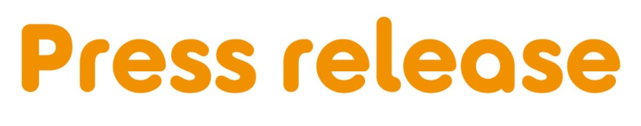

[Insert date]

[Insert name of town/area] [woman/man/friends/group] to [hold a bake sale/black tie ball/] to help people facing breast cancer

[Name] from [Location] is holding a [insert event] at [Venue] on [Date] for Breast Cancer Care – the only UK-wide specialist breast cancer support charity.

[Name], [Age] is holding [his/her/their] [first/second/third annual event] and is encouraging local residents to come along and support people facing breast cancer.

[Name] who works as an [occupation] says: [Select any of the following 3 options, edit or expand to two sentences if you want.]

“My [family member/friend] was diagnosed with breast cancer in [month/year] and I am looking forward to giving something back by holding a [insert activity] to raise money for Breast Cancer Care.”

OR “I was diagnosed with breast cancer in [month/year] and I am looking forward to holding a [insert activity] to say thank you to my friends and family for their support, while raising money for Breast Cancer Care.”

OR “I am looking forward to holding a [insert event] as it’s a fun way to bring together people from the local community while also raising money for Breast Cancer Care.”

“We’d love locals to join us for some [delicious home-baked treats/games/competitions].”

Alec Raven, Head of Community Fundraising at Breast Cancer Care, added: “We’re so grateful to [Name] for holding a community event in aid of Breast Cancer Care. The money raised will help Breast Cancer Care to continue to provide free services including; support over the phone with a nurse or someone who’s been there, welcoming online forums, reliable information and local group support.

“691,000 people are living with a breast cancer diagnosis in the UK today, and that figure is only set to grow. With support from people like [Name], we can be here for more people, whenever they need us.”

If you would like to attend [insert event], please call [phone number] or email [email address].

OR

[Name]’s event is being held at [Full address] on [insert date] between [time-time], locals are welcome to drop by.

For breast cancer care, information and support visit www.breastcancercare.org.uk

– Ends –

For further information, images or interviews contact:

[Name], [Phone number], [Email address]

About Breast Cancer Care

When you have breast cancer, everything changes. Time becomes measured in appointments. The next scan. The next results. The next challenge.

At Breast Cancer Care, we understand the emotions, challenges and decisions you face every day. So, from the day you notice something’s not right to the day you begin to move forward, we’ll be here to help you through.

Whether you want to speak to our nurses, download our specialist information or connect with volunteers who have faced what you are facing now, we can help you feel more in control.

For care, support and information from day one, call us free on 0808 800 6000 or visit breastcancercare.org.uk

