Top Tips: Use this press release after your event to let people know how much you raised to support people affected by breast cancer.

Edit the sections in pink with your own information and email it to your local newspaper and radio station as soon as you can after your event along with photos of your Big Pink. Don’t forget to proofread before sending and remove any pink text and instructions.
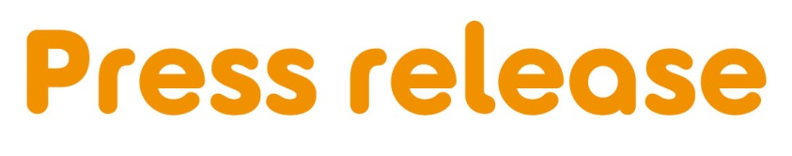
[Insert date]
[town/area] [woman/ man/ friends/ company] raised [£XXX] to support people facing breast cancer
[Name] from [Location] held a Big Pink party at [Venue] with [family and friends/colleagues/ neighbours] and raised an amazing total of [£XXX] for Breast Cancer Care – the only UK-wide specialist breast cancer support charity.
[Name], [age] held the party on [date] because [Select any of the following 3 options, feel free to expand: he/she has a friend/family member who has had breast cancer. OR he/she was diagnosed with breast cancer. OR he/she wanted to support the charity in Breast Cancer Awareness Month].
[Name] who works as a [Occupation] says: “Everyone had a wonderful time at the Big Pink party, around [number] people joined us. I’d like to thank everyone who baked treats and helped out and I am truly grateful to all those who supported us and donated to Breast Cancer Care, it means so much.”
Samia al Qadhi, Chief Executive of Breast Cancer Care, added: “We’re so grateful to everyone for holding a Big Pink party in aid of Breast Cancer Care. All the money raised will enable us to continue to provide vital support to the 62,000 people diagnosed with breast cancer in the UK every year.”
Want to hold your own Big Pink party for Breast Cancer Care? It can be as simple as a pink night in at home, a bake sale with your colleagues or a pink party in the community. Big or small, the money you raise will help Breast Cancer Care to transform the lives of people affected by the disease.
Sign up today for your free fundraising kit at www.breastcancercare.org.uk/October
– Ends –

For further information, images or interviews contact:
[Name], [Phone number], [Email address]

About Breast Cancer Care
Breast Cancer Care is the only specialist UK wide charity providing support for women, men, family and friends affected by breast cancer. We’ve been caring for them, supporting them, and campaigning on their behalf since 1973.
Today, we continue to offer a unique range of support including reliable information, one-to-one support over the phone and online from nurses and people who’ve been there. We also offer local group support across the UK.
From the moment someone notices something isn’t right, through to their treatment and beyond, we’re there to help people affected by breast cancer feel more in control. breastcancercare.org.uk

