Top Tips: Use this press release before your event if you would like to invite local people to attend.
Edit the sections in pink with your own information and email it to your local newspaper and radio station around two weeks before your event. Don’t forget to proof read before sending and remove any pink text and instructions.
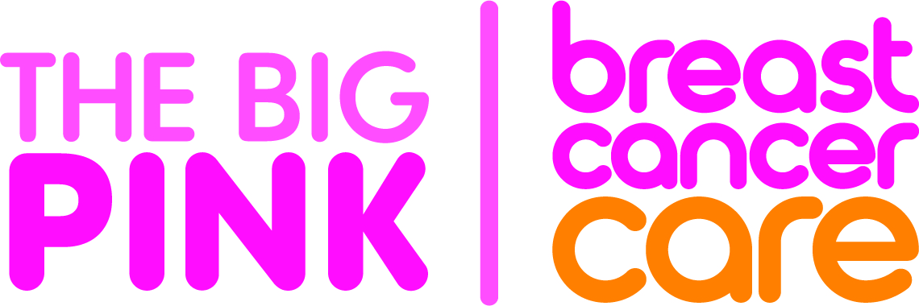
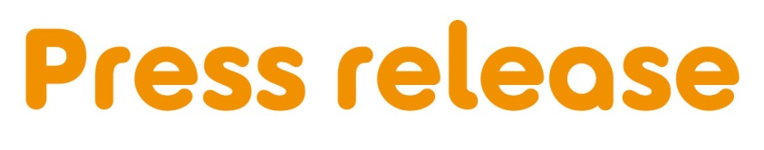
[Insert date]
[town/area] [woman/ man/ friends/ company] to host a Big Pink party to support people facing breast cancer
[Full Name/ Company name] from [Location] is [hosting a/ inviting locals to join their] Big Pink party at [Venue] on [Date] to raise money and awareness for Breast Cancer Care – the only UK-wide specialist breast cancer support charity, for Breast Cancer Awareness Month this October.
[First Name], [Age] is holding [his/her/their] [first/second/third annual] Big Pink party and is encouraging people to come along and support the charity.
[Name] who works as an [occupation] says: [Select any of the following three options, edit or expand if you want].
“My [family member/ friend/ colleague] was diagnosed with breast cancer in [month/ year] and I am looking forward to giving something back by hosting a Big Pink party to raise money for Breast Cancer Care.”
OR “I was diagnosed with breast cancer in [month/ year] and I am looking forward to hosting a Big Pink party to say thank you to my [friends and family/ colleagues] for their support, while raising money for Breast Cancer Care.”
OR “I am looking forward to holding a Big Pink party as it’s a fun way to bring together people from the local community while also raising awareness and money for Breast Cancer Care.”
“We’d love locals to join us for some delicious pink treats. [Include if relevant]: There will also be games and competitions too so there’s something for everyone.”
Samia al Qadhi, Chief Executive of Breast Cancer Care, added: “We’re so grateful to everyone for holding a Big Pink party in aid of Breast Cancer Care. All the money raised will enable us to continue to provide vital support to the 62,000 people diagnosed with breast cancer in the UK every year.”
If you would like to attend [Name]’s Big Pink party, please call [phone number]
[Or]
[Name]’s Big Pink party is being held at [Full address] on [insert date] between [time-time]/ at [time], locals are welcome to drop by.
Want to hold your own Big Pink party for Breast Cancer Awareness Month this October? It can be as simple as a pink night in at home, a bake sale with your colleagues or a pink party in the community. Big or small, the money you raise will help Breast Cancer Care to transform the lives of people affected by the disease.
Sign up today for your free fundraising kit at www.breastcancercare.org.uk/October
– Ends –

For further information, images or interviews contact:
[Name], [Phone number], [Email address]

About Breast Cancer Care
Breast Cancer Care is the only specialist UK wide charity providing support for women, men, family and friends affected by breast cancer. We’ve been caring for them, supporting them, and campaigning on their behalf since 1973.
Today, we continue to offer a unique range of support including reliable information, one-to-one support over the phone and online from nurses and people who’ve been there. We also offer local group support across the UK.
From the moment someone notices something isn’t right, through to their treatment and beyond, we’re there to help people affected by breast cancer feel more in control. breastcancercare.org.uk

